3-Tier Architecture:

An 3-Tier Architecture program is one that is distributed among three or more separate computers in a distributed network.

The most common form of n-tier is the 3-tier Application, and it is classified into three categories.

* User interface programming in the user's computer
* Business logic in a more centralized computer, and
* Required data in a computer that manages a database.

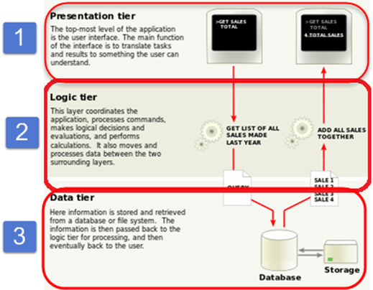

The above **3-tier architecture**has three different layers.

* Presentation layer
* Business Logic layer
* Database layer

Here we have taken a simple example of student form to understand all these three layers. It has information about a student like – Name, Address, Email, and Picture.

* **User Interface Layer or Presentation Layer**

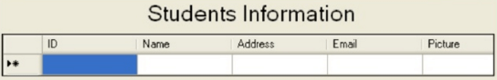

**Business Access Layer -**

This is the function of the business layer which accepts the data from the application layer and passes it to the data layer.

* Business logic acts as an interface between Client layer and Data Access Layer
* All business logic – like validation of data, calculations, data insertion/modification are written under business logic layer.
* It makes communication faster and easier between the client and data layer
* Defines a proper workflow activity that is necessary to complete a task.

**Data Access Layer**

* This is the data layer function, which receives the data from the business layer and performs the necessary operation into the database.

**Advantages and Disadvantages of Three-Tier Architectures**

|  |  |
| --- | --- |
| **Advantages** | **Disadvantages** |
| * Scalability | * Increase in Effort |
| * Data Integrity | * Increase in Complexity |
| * Reusability |  |
| * Reduced Distribution |  |
| * Improved Security |  |
| * Improved Availability |  |